Cell Structure

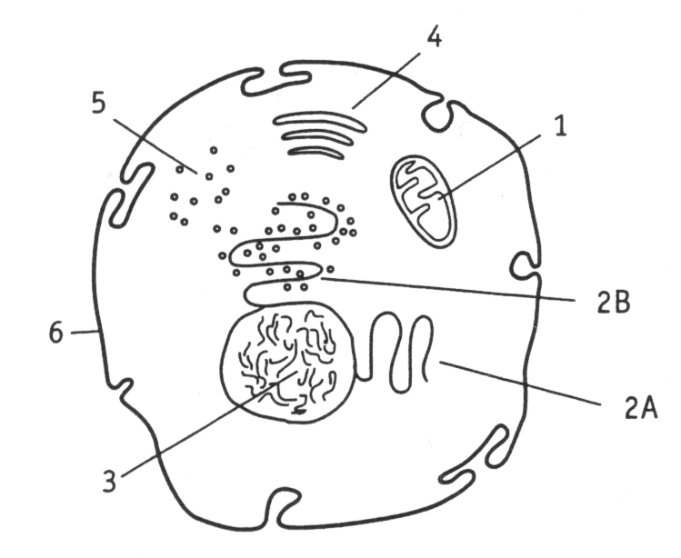

To the right is a diagram of a typical animal cell. Using you textbook as a guide, complete the following table.

Two important organelles are missing from the diagram. Find out the structure and function of centrioles and lysosomes and add these to the table.

|  |  |  |  |
| --- | --- | --- | --- |
| Organelle number | Organelle name | Electron microscope image | Organelle function |
| 1 |  | Mitochondria |  |
| 2A |  | Smooth ER |  |
| 2B |  | Rough ER |  |
| 3 |  | Nucleus |  |
| 4 |  | Golgi apparatus |  |
| 5 | Ribosomes |  |  |
| 6 | Cell membrane | Nuclear membrane |  |
| 7 |  |  |  |
| 8 |  |  |  |

**Cell membrane: structure and transport**

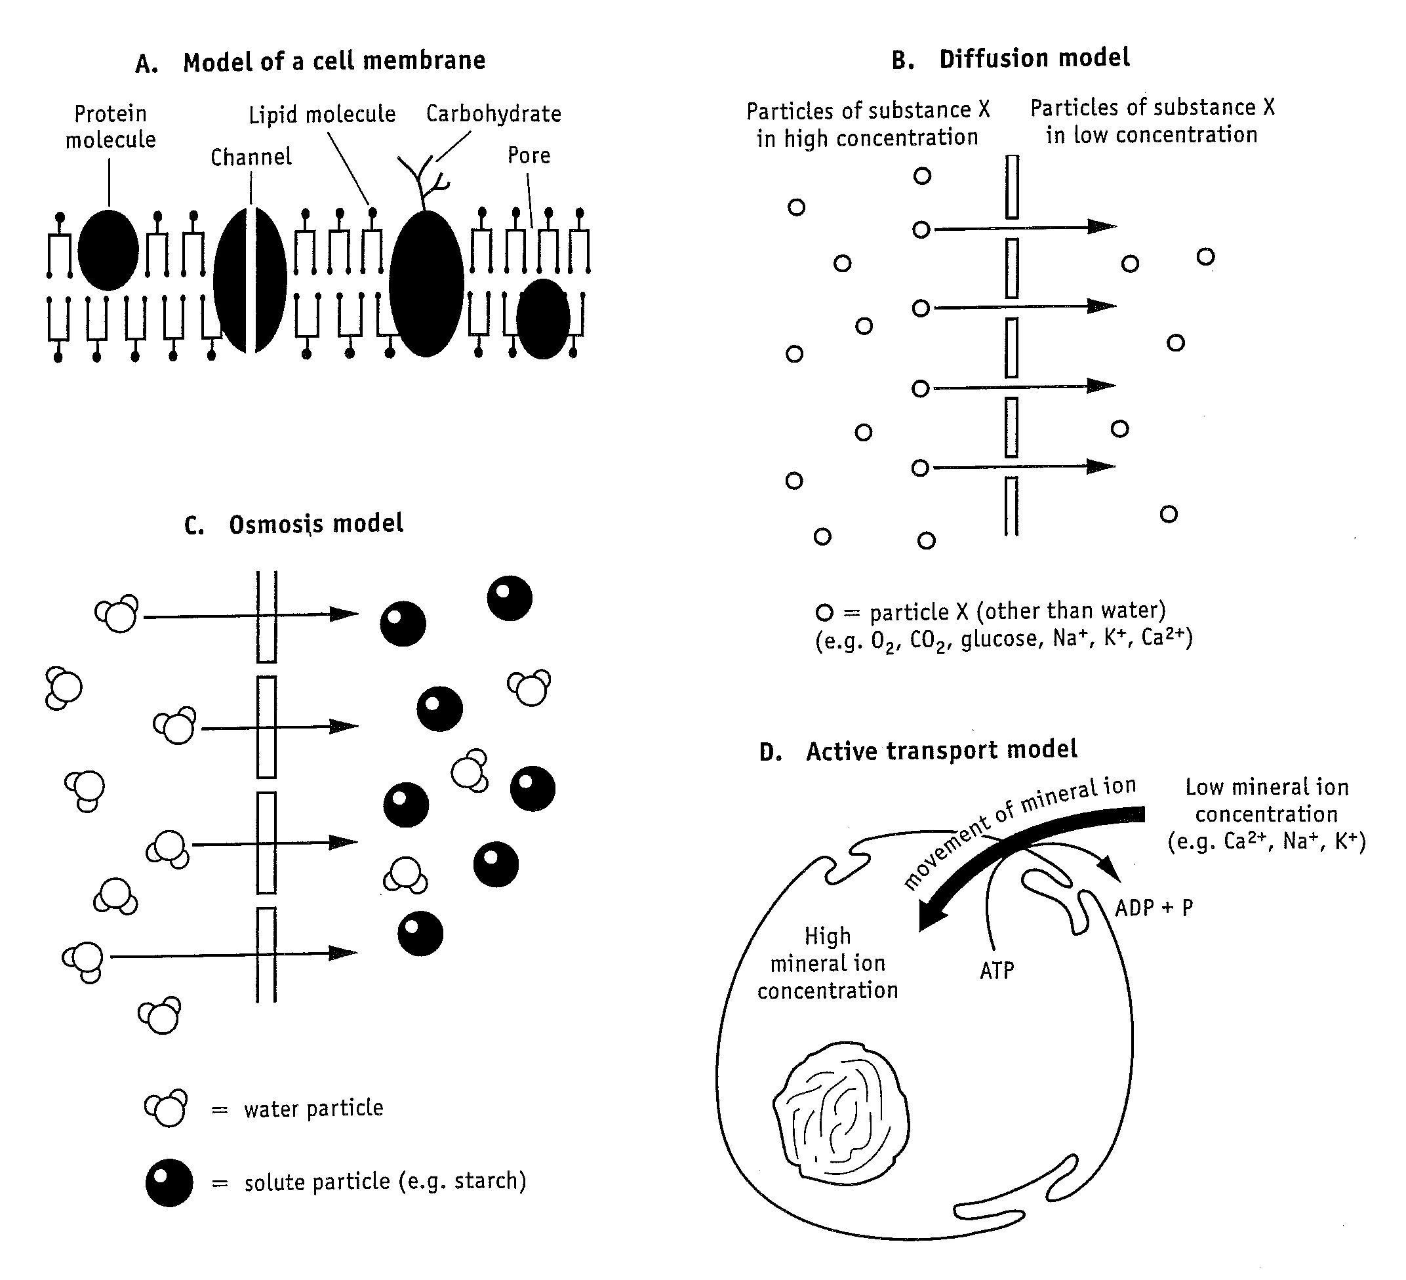

1. Describe two features of the cell membrane that aid the movement of nutrients into a cell.
2. Define diffusion
3. Explain what happens during osmosis
4. List two ways in which active transport is different to passive transport (e.g. diffusion and osmosis)
5. Sodium can enter cells by diffusion or active transport. If the concentration of sodium was relatively high outside a cell, which method would be used?
6. If a red blood cell was dropped in a test tube full of pure water what would happen to the cell in terms of osmosis?
7. For each of the substances listed below, select the correct type of membrane transport. Choose from: diffusion, osmosis, facilitated diffusion, active transport or vesicular.

|  |  |
| --- | --- |
| Substance | Type of Transport |
| Oxygen |  |
| Testosterone (fat-soluble hormone) |  |
| Glucose |  |
| Water |  |
| Amino acid |  |
| A large protein |  |

1. If the average osmolality of a cell is 322 mOsm, what would you expect to happen if it were placed in a solution with an osmolality of 476 mOsm?

**Calculating size**

Look at the diagrams of cells and bacteria drawn in the fields of view below. The lines in the grids are 100µm apart.

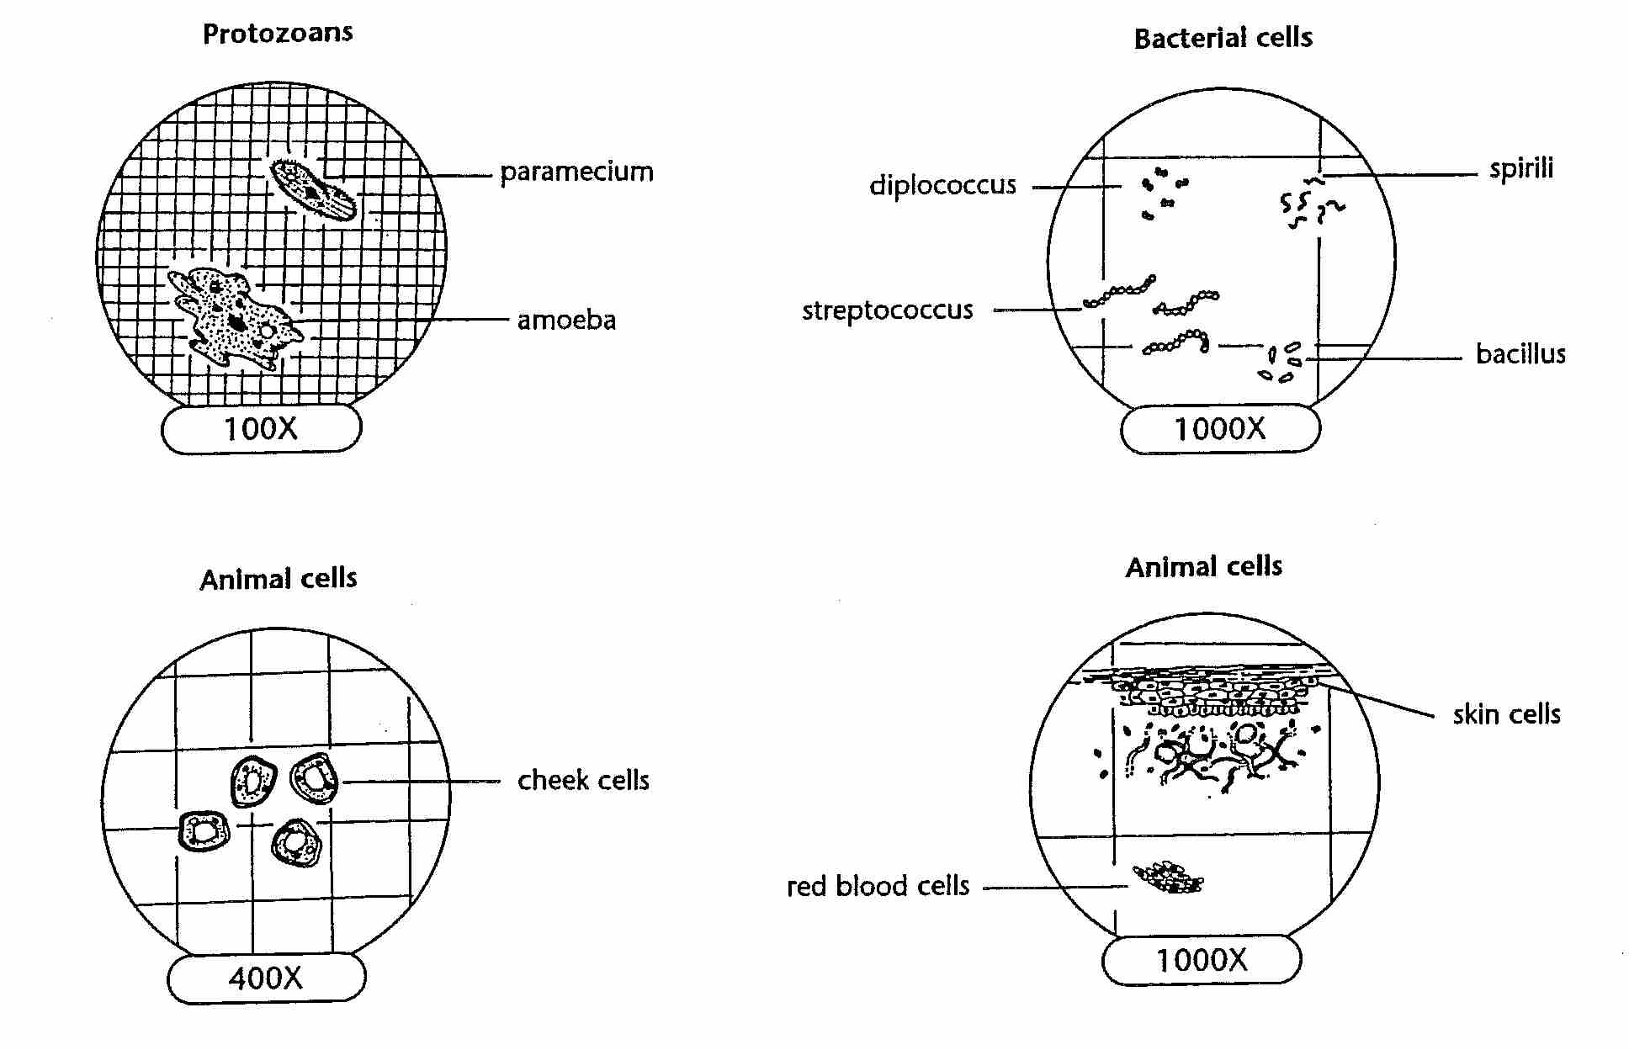

1. Use the grids to estimate the length and width of each cell. Record your answers in the table below

|  |  |  |  |  |  |
| --- | --- | --- | --- | --- | --- |
| Cell type | Length | Width | Bacteria | Length | Width |
| Cheek |  |  | Diplococcus |  |  |
| Skin |  |  | Spirili |  |  |
| Red Blood |  |  | Streptococcus |  |  |
| Paramecium |  |  | Bacillus |  |  |
| Amoeba |  |  |  |  |  |
| Average |  |  | Average |  |  |

1. Explain why it is important for cells to be microscopic in size?

**The Kidneys**

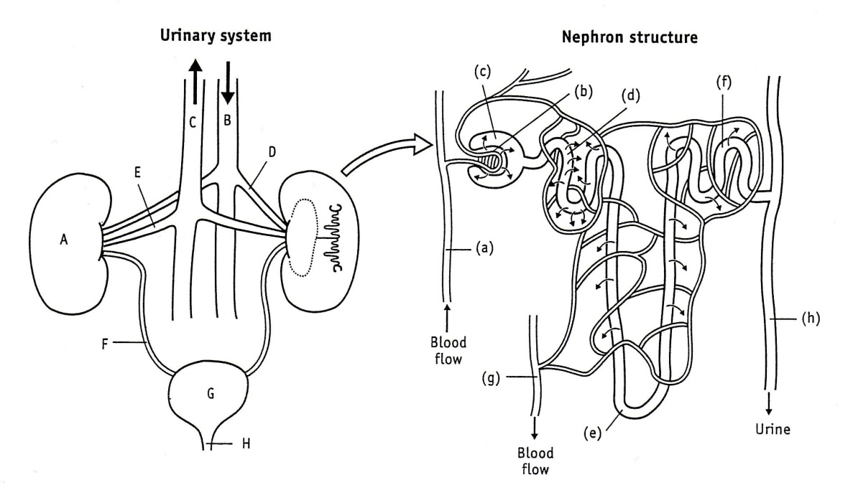

1. Write down the name and function of each component of the urinary system.

|  |  |  |
| --- | --- | --- |
|  | Name | Function |
| A |  |  |
| B |  |  |
| C |  |  |
| D |  |  |
| E |  |  |
| F |  |  |
| G |  |  |
| H |  |  |

1. Write down the name and function of each component of the nephron.

|  |  |  |
| --- | --- | --- |
|  | Name | Function |
| a |  |  |
| b |  |  |
| c |  |  |
| d |  |  |
| e |  |  |
| f |  |  |
| g |  |  |
| h |  |  |

1. List the main chemical substances that are forced out of the blood into structure (c) in the nephron
2. How are these substances forced out of the blood at point (b)?
3. List the main substances that are reabsorbed from the nephron back into the blood at point (d).
4. Which membrane transport processes would help with this reabsorption process?
5. Name the main metabolic waste substance that is not reabsorbed back into the blood.
6. What would be the main difference between the composition of the blood in the following pairs of blood vessels?
7. Renal artery and renal vein
8. Renal arteriole and renal venule

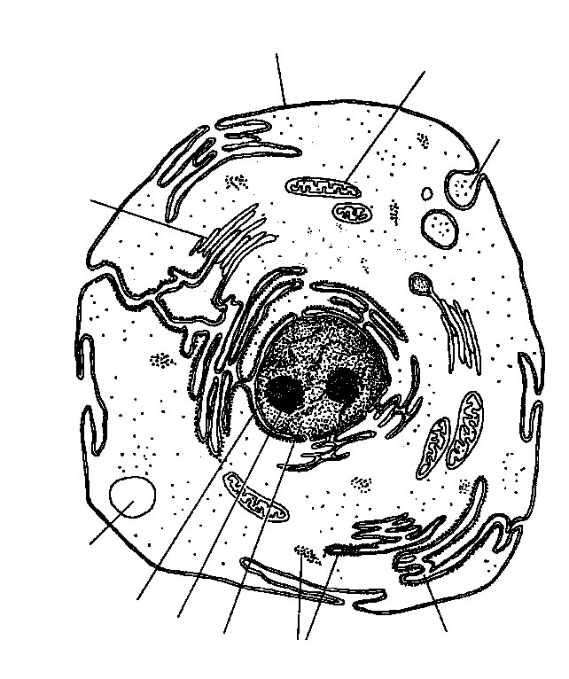

**Mitosis**

Look at the picture showing cells in various stages of mitosis. Identify cells in the stages of interphase, prophase, metaphase, anaphase and telophase.

1. Draw sketches of each stage in the table below and label the parts that are listed.

|  |  |
| --- | --- |
| Interphase Label: nucleus, chromatin, cytoplasm |  |
| Prophase Chromosomes, spindle |  |
| Metaphase Chromosomes, spindle |  |
| Anaphase Chromosomes, spindle |  |
| Telophase Nuclei of daughter cells, point of cytokinesis |  |

1. In what phases do the following changes in DNA begin?

|  |  |
| --- | --- |
| DNA replication occurs |  |
| Chromosomes condense (and thus become visible) |  |
| Chromosomes uncoil |  |
| Sister chromatids are attached to the centromere |  |
| Centromere divides and the sister chromatids separate |  |

1. In what phases do the following changes in cell structure take place?

|  |  |
| --- | --- |
| Breakdown of nuclear envelope |  |
| Spindle forms |  |
| Nuclear membrane re-forms |  |
| Cytokinesis occurs |  |

1. Identify the stage of mitosis for each of the cells below.

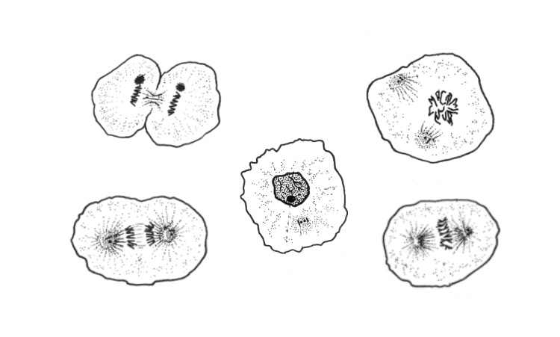

A

B

C

D

# E

Cells in an onion root tip showing the various stages of mitosis.

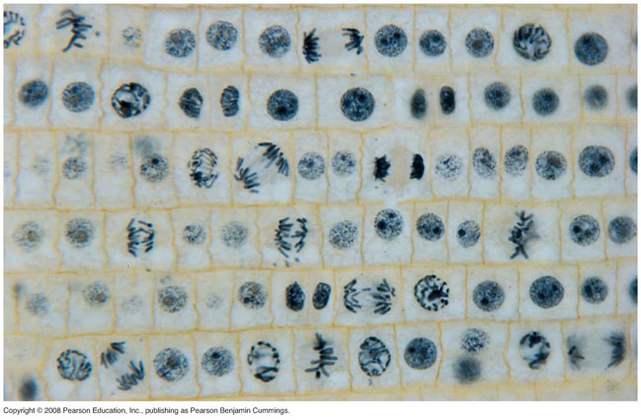

Cellular Respiration: Energy Systems

|  |  |  |  |
| --- | --- | --- | --- |
|  | Anaerobic | | Aerobic (oxidative phosphorylation) |
|  | Phosphagen (creatine phosphate) | Glycogen-lactic (glycolysis) |
| Oxygen required (Yes/No) |  |  |  |
| Relative Speed  (Fast, intermediate, slow) |  |  |  |
| Number of chemical reactions |  |  |  |
| Duration  (For how long can the system produce energy?) |  |  |  |
| Reactants |  |  |  |
| Products |  |  |  |
| Location in cell |  |  |  |
| Examples of activities that would use this system |  |  |  |